Town of Swampscott
Finance Committee Meeting Minutes
Wednesday, May 3rd, 2023 - 7:00 PM
Virtual meeting

FINANCE COMMITTEE MEMBERS PRESENT
Eric Hartmann (Chair), Matthew Kirschner (Vice-chair), Naomi Dreeben, Joan Hilario, Suraj Krishnamurthi, Cinder McNerney, Adrian Rodriguez, Erik Schneider.

FINANCE COMMITEE MEMBERS ABSENT
Sunit Shah.

OTHER TOWN STAFF
Amy Sarro, Director of Admin. & Finance; Patrick Luddy, Town Treasurer/Collector; Trang Vu, Assistant Town Accountant

The meeting was called to order at 7:04 PM

Public comment
None

Potential vote on Town Meeting Warrant

Chairman Hartmann commented that we can skip the 3 articles that we haven’t voted on and do it next meeting since the Selectboard is still discussing them. The plan for tonight is to determine who will speak to each warrant article.

Amy Sarro reminded the committee that only Fincom members who are Town Meeting members can make motion.

Erik Schneider asked the financial implications going forward regarding land acquisition and disposition articles.
Eric Hartmann commented that the idea is we would buy the land for $1.76M and find a non-profit developer. They will develop the property into the low income/veterans housing preference for Swampscott residents. There will be no more financial liability from the town. He hoped this would be clarified and presented by the Selectboard before the Town Meeting.

Cinder McNerney mentioned the bonding language in article #10. Amy Sarro said the Selectboard, before closing the warrant, was not sure of the amount that would come from the Affordable Housing Trust and ARPA. Therefore, the language is recommended to be used by the town counsel.

Ms. McNerney and Mr. Hartmann both mentioned there is no language indicating the use of the ARPA fund in this article.

Erik Schneider commented that if it includes bonding language, we should do that analysis as we did for the new school and other property. We cannot just have town meeting approved bond language without the analysis even if it is not intended.

Cinder McNerney commented that the Finance Committee should see the motion language and have a chance to discuss it instead of having it at the same night of Town Meeting.

Responding to Matthew Kirschner’s question, Eric Hartmann commented that he does not think the intent of land acquisition and disposition is a money maker. It is to help us meet our affordable housing and veteran housing needs and improve the not very good-looking plot of land in the neighborhood. The fact that we have ARPA fund available is also a driver.

Discussing article #13, the extension of use: Hawthorne by the Sea, there was an idea exchange last week. Naomi Dreeben commented that it was a well-attended event with 3 options promoted. There was no talk about the cost.

After some discussion, the following are the articles presented by Finance Committee members:
Article #3, #4: Eric Hartmann
Article #5, #6: Naomi Dreeben
Article #7, #8, #9: Adrian Rodriguez
Article #13, #14: Naomi Dreeben
Article #15, #16: Cinder McNerney
Article #10 to #12 would be decided after the committee has official motion language and takes votes on them.

There was a discussion about FY2024 projected revenue.

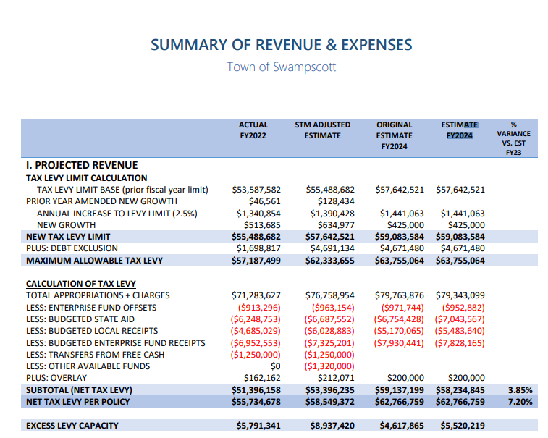

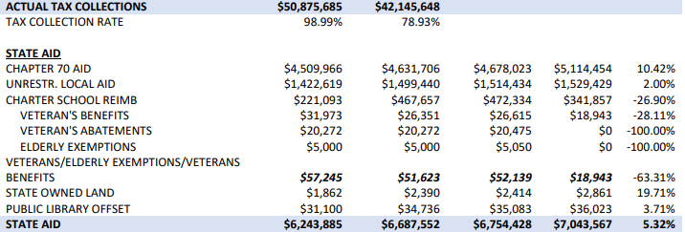

Amy Sarro commented that the difference between the original and estimate is reflective of the State Aid change with the governor’s budget.
Enterprise fund offset is slightly different because we had the updated number from the MWRA after we closed the warrant. Other changes reflect any changes made to the Finance Committee recommended budget.

Cinder McNerney asked while the Special Town Meeting actual receipts were around $6M, we are only estimating $5.483M for FY2024. Amy Sarro commented that as part of setting tax rate, we were able to recognize actual receipts to date and trend from there. Whereas, when setting up the budget, we are only allowed to go based off multiple-year trend. We are not anticipating less but if there is a giant meals and rooms taxes, we would be able to use that trend to project to end of year conservatively and recognize higher budgeted local receipts to thus reduce the tax levy. This is why we do the tax rate in the fall because we have a better picture of those numbers.

Erik Schneider asked the difference between the Subtotal (Net Tax Levy) and Net Tax Levy per Policy. Amy Sarro commented that the Net Tax Levy per Policy is 2% plus 425,000 while the Subtotal is just the calculation that we see in the calculation of the tax levy.

Responding to Mr. Kirschner’s comment of $5M expected increased taxes next year by looking at the excess levy capacity. Mr. Hartmann said we should not jump straight to that conclusion since we are not setting the tax rate right now and have not done anything with any potential reserves. This is a conservative revenue estimate that is not necessarily aligned with what history has been.

Erik Schneider commented that we use updated projections of receipts in a special town meeting when we are setting the rates, that will leave us less room later to have free cash. Amy Sarro confirmed that comment. Mr. Schneider said we should think about it in the fall if we again use the updated projections.

Amy Sarro mentioned the plan to change the format of the revenue sheet next year since it only makes sense for internal staff when inputting data into the DOR website but might be confusing for other people.

Old and new business

Chairman Hartmann mentioned the office hours held by the Town Moderator next week via Zoom so that people ask questions before the Town Meeting. He will try to be there as often as possible but ask if any Finance Committee members can volunteer as well.

On MOTION (Cinder McNerney) and SECONDED (Suraj Krishnamurthi), it was VOTED to adjourn the meeting at 8:35 PM by ROLL CALL.
ROLL CALL: Naomi Dreeben (YES), Adrian Rodriguez (YES), Matthew Kirschner (YES), Joan Hilario (YES), Erik Schneider (YES), Eric Hartmann (YES).

True Attest,

Trang Vu

Assistant Town Accountant

Approved by vote of the finance committee 09/19/2023.

